Boeing LifeWorks Contact Stress Retardation Model Validation
Crack Growth with Spectrum Loading Prediction Challenge 2022

Introduction
The purpose of this effort is a progressive validation of available methods used to predict crack growth under complex loading. Accurately predicting overload induced retardation effects on crack growth rate is an essential step towards the full incorporation of engineered residuals (and related life improvements) into analysis required to certify structural integrity of aircraft. The test configurations and data presented in this document were originally used for the validation of Boeing LifeWorks Contact Stress Model which predicts crack closure, retardation, acceleration and other load interaction effects.
This document contains the background and data required to participate in a crack growth prediction challenge. The challenge includes 2 prediction tasks using different spectra. It is up to the participant to include one or both tasks in their submission.
Instructions
The goal of this challenge is to predict crack growth as a function of length (see Submission Templates in the Appendix A). The participant is free to use the tools and processes of their preference to make such predictions. Aluminum 7075-T651 crack growth rate data is provided for different stress ratios (see Appendix B). It is up to the participant to use the data provided or to use growth rate from a different source, in which case the provided data could be used as reference. Participants should provide the details of their analysis inputs and assumptions. When possible, it is encouraged to include details on the software and modeling used.
Test specimen
For this effort twenty one specimens with the center crack tension configuration shown in Figure 1, were manufactured from aluminum alloy 7075-T651.
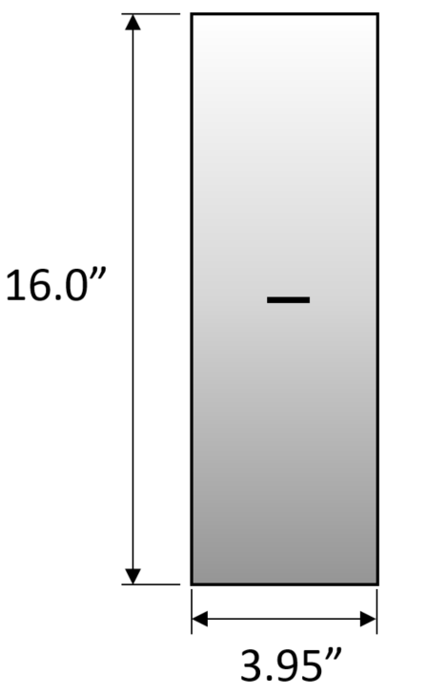
Figure 1 Center crack in tension configuration
Raw Growth Rate Data
Ten specimens were subjected to room temperature constant amplitude fatigue testing in accordance with ASTM, Standard Test Method E647. The specimens were tested at various stress levels and the specimen crack length was recorded at increments of 0.05 inches throughout the test to specimen failure. After completion of testing, the crack growth rates and corresponding stress intensities were determined in accordance with E647. Crack growth rate versus stress intensity, da/dN versus delta K, are presented in Figure 2. The growth rate data is provided in tabulated format in Appendix B.
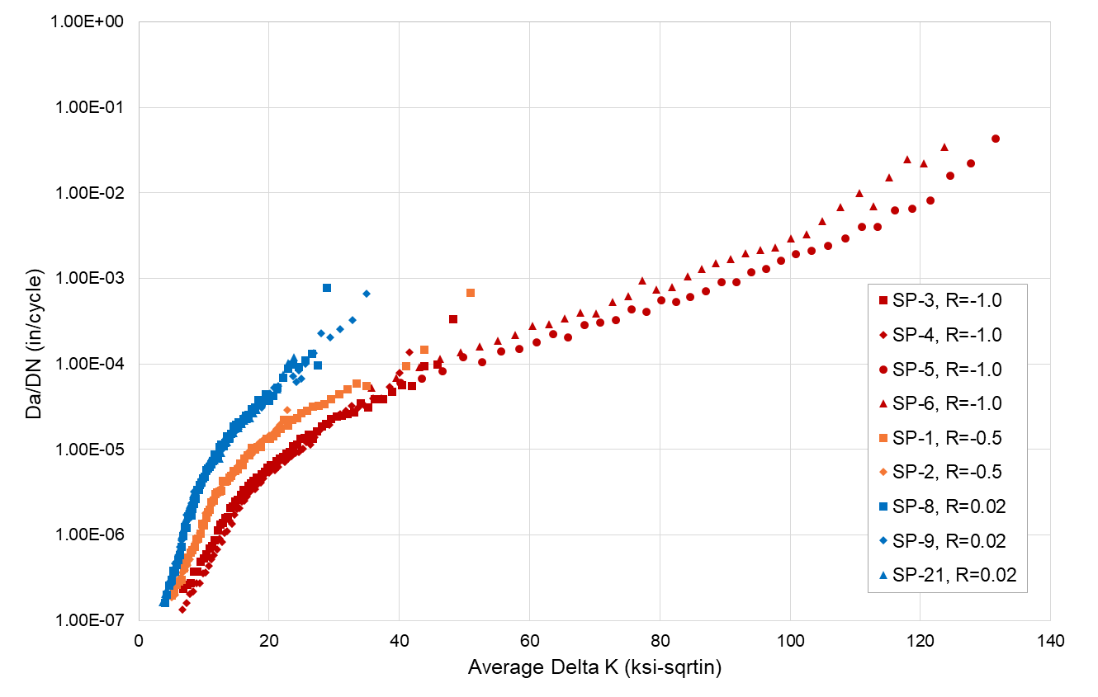
Figure 2 7075-T651 Task A Crack Growth Rate

Challenge Task A: Constant Amplitude with Spike Overloads Prediction
Three (3) specimens were tested using a constant amplitude spectrum (R = 0, Smax = 15 ksi) with overloads (1.5*Smax = 22.5 ksi) inserted every 100 cycles. The specimens configuration data is provided in Table 1.
Table 1 Task A Testing Configuration
Configuration | Specimen Thickness (in) | Specimen Width (in) | Stress Level (ksi) | Stress Ratio | Test Type
A | 0.245 | 3.950 | 15.0 | 0.0 | Overload

Challenge Task B: Fighter Lower Wing Spectrum
Four (4) specimens were tested using spectrum characteristic of Boeing fighter lower wing structure. Lateral supports were used for all lower wing spectrum specimens. A roadmap of the normalized (P/Pmax) spectrum used is shown in Figure 3. The normalized spectrum data is provided in time history format in the excel file provided (ERSI_BoeingCSMVerificationPrediction_Data.xlsx). This spectrum represents 1000 Flight Hours of fighter aircraft usage.
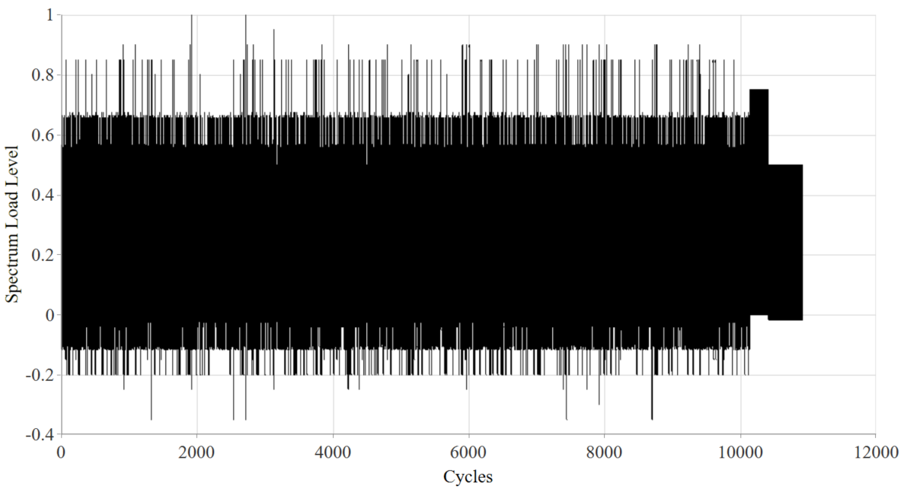
Figure 3 Fighter Lower Wing Spectrum

The specimens configuration data for task B is provided in Table 2.

Table 2 Task B Testing Configurations
Configuration | Specimen Thickness (in) | Specimen Width (in) | Stress Level (ksi) | Test Type
B | 0.246 | 3.960 | 25.0 | Lower Wing

Deadline to Submit Results:
Result submissions must be received before 12/02/2022.
Contact Information:
All questions and final submissions should be send to moises.y.ocasio-latorre@boeing.com

Appendix A: Spectrum Loading Prediction Challenge Submission Template

Point of Contact
Full Name | First-Name Last-Name
Email | name@email.com
Affiliation | Institution Name

Task A Analysis Details

Analysis Method Overview
- handbook beta solution 2D[ref], through thickness crack
- material input data [ref]
- AFGROW v##, min-max cycle-by-cycle growth, output crack growth from ai to failure

Material Properties
- E, v, KIC etc.
- Da/dn vs DK curve
- Etc

Assumptions
- Initial Crack size, aspect ratio
- Failure criterion
- 2D/3D solution
- Retardation/acceleration model
- Etc.

Methodologies
- LEFM, E/PFM etc.

Tools/Software Details
- NASTRAN v##, AFGROW v###, internal code etc.

Other Information
- Material model, geometry model etc.

Results

Failure Modes
- Summary of failure modes

Task A Crack Growth Curves

Cycles | Crack Length a, [in]
0
1000
2000
3000
…
Failure

Task B Analysis Details

Analysis Method Overview
- handbook beta solution 2D[ref], through thickness crack
- material input data [ref]
- AFGROW v##, min-max cycle-by-cycle growth, output crack growth from ai to failure

Material Properties
- E, v, KIC etc.
- Da/dn vs DK curve
- Etc

Assumptions
- Initial Crack size, aspect ratio
- Failure criterion
- 2D/3D solution
- Retardation/acceleration model
- Etc.

Methodologies
- LEFM, E/PFM etc.

Tools/Software Details
- NASTRAN v##, AFGROW v###, internal code etc.

Other Information
- Material model, geometry model etc.

Results

Failure Modes
- Summary of failure modes

Task B Crack Growth Curves

Hours | Crack Length a, [in]
0
1000
2000
3000
…
Failure

Appendix B: 7075-T651 da/dN versus delta K

SP-3, R=-1.0 |  | SP-4, R=-1.0 |  | SP-5, R=-1.0 |  | SP-6, R=-1.0
Average Delta K (ksi-sqrtin) | Da/DN (in/cycle) | Average Delta K (ksi-sqrtin) | Da/DN (in/cycle) | Average Delta K (ksi-sqrtin) | Da/DN (in/cycle) | Average Delta K (ksi-sqrtin) | Da/DN (in/cycle)
6.85 | 2.34E-07 | 6.74 | 1.33E-07 | 40.11 | 6.04E-05 | 35.73 | 5.27E-05
7.45 | 2.64E-07 | 7.33 | 1.62E-07 | 43.45 | 6.80E-05 | 39.58 | 6.90E-05
8.01 | 2.76E-07 | 7.88 | 2.03E-07 | 46.66 | 8.23E-05 | 43.08 | 9.13E-05
8.51 | 3.72E-07 | 8.41 | 2.20E-07 | 49.77 | 1.21E-04 | 46.31 | 1.16E-04
9 | 3.70E-07 | 8.92 | 2.72E-07 | 52.73 | 1.06E-04 | 49.36 | 1.37E-04
9.48 | 4.88E-07 | 9.39 | 2.76E-07 | 55.68 | 1.41E-04 | 52.29 | 1.60E-04
9.95 | 5.28E-07 | 9.84 | 3.56E-07 | 58.4 | 1.51E-04 | 55.14 | 1.89E-04
10.41 | 5.90E-07 | 10.29 | 3.68E-07 | 61.02 | 1.81E-04 | 57.85 | 2.17E-04
10.85 | 7.01E-07 | 10.72 | 4.39E-07 | 63.56 | 2.24E-04 | 60.44 | 2.80E-04
11.28 | 7.49E-07 | 11.14 | 5.16E-07 | 65.95 | 2.04E-04 | 62.94 | 2.92E-04
11.7 | 8.76E-07 | 11.57 | 5.76E-07 | 68.44 | 2.83E-04 | 65.37 | 3.45E-04
12.1 | 1.14E-06 | 11.99 | 6.86E-07 | 70.85 | 3.08E-04 | 67.83 | 4.00E-04
12.5 | 1.31E-06 | 12.38 | 9.00E-07 | 73.2 | 3.23E-04 | 70.18 | 3.89E-04
12.9 | 1.39E-06 | 12.76 | 8.27E-07 | 75.65 | 4.37E-04 | 72.7 | 5.32E-04
13.3 | 1.58E-06 | 13.17 | 1.05E-06 | 77.97 | 4.09E-04 | 75.2 | 6.16E-04
13.7 | 1.63E-06 | 13.56 | 1.10E-06 | 80.16 | 5.57E-04 | 77.34 | 9.48E-04
14.08 | 2.07E-06 | 13.95 | 1.47E-06 | 82.44 | 5.32E-04 | 79.46 | 7.44E-04
14.47 | 2.17E-06 | 14.33 | 1.34E-06 | 84.71 | 6.12E-04 | 81.83 | 7.86E-04
14.86 | 2.45E-06 | 14.7 | 1.73E-06 | 87.02 | 7.05E-04 | 84.27 | 1.05E-03
15.26 | 2.60E-06 | 15.09 | 2.00E-06 | 89.42 | 9.01E-04 | 86.47 | 1.30E-03
15.65 | 2.95E-06 | 15.48 | 2.04E-06 | 91.75 | 9.08E-04 | 88.57 | 1.52E-03
16.04 | 3.37E-06 | 15.86 | 2.48E-06 | 94.04 | 1.18E-03 | 90.84 | 1.70E-03
16.43 | 3.22E-06 | 16.25 | 2.50E-06 | 96.34 | 1.30E-03 | 93.18 | 1.97E-03
16.84 | 3.73E-06 | 16.65 | 2.84E-06 | 98.57 | 1.61E-03 | 95.45 | 2.14E-03
17.24 | 4.05E-06 | 17.05 | 3.19E-06 | 100.89 | 1.92E-03 | 97.73 | 2.32E-03
17.65 | 4.32E-06 | 17.45 | 3.71E-06 | 103.31 | 2.13E-03 | 100.18 | 2.97E-03
18.06 | 4.69E-06 | 17.86 | 3.41E-06 | 105.85 | 2.43E-03 | 102.54 | 3.29E-03
18.48 | 4.73E-06 | 18.28 | 3.92E-06 | 108.48 | 2.96E-03 | 105 | 4.67E-03
18.91 | 5.16E-06 | 18.7 | 4.06E-06 | 111.02 | 4.03E-03 | 107.71 | 6.92E-03
19.34 | 5.48E-06 | 19.12 | 4.62E-06 | 113.49 | 4.03E-03 | 110.6 | 1.01E-02
19.78 | 6.13E-06 | 19.57 | 5.20E-06 | 116.04 | 6.24E-03 | 112.85 | 7.07E-03
20.24 | 6.49E-06 | 20.01 | 5.31E-06 | 118.75 | 6.59E-03 | 115.15 | 1.52E-02
20.69 | 6.46E-06 | 20.46 | 5.94E-06 | 121.5 | 8.10E-03 | 118.05 | 2.49E-02
21.16 | 7.38E-06 | 20.93 | 5.68E-06 | 124.62 | 1.60E-02 | 120.58 | 2.22E-02
21.64 | 7.83E-06 | 21.42 | 6.29E-06 | 127.7 | 2.21E-02 | 123.71 | 3.45E-02
22.13 | 8.23E-06 | 21.92 | 7.41E-06 | 131.59 | 4.36E-02
22.64 | 8.95E-06 | 22.41 | 7.22E-06
23.16 | 9.35E-06 | 22.92 | 7.84E-06
23.73 | 1.09E-05 | 23.47 | 8.44E-06
24.29 | 1.14E-05 | 24.02 | 9.23E-06
24.84 | 1.32E-05 | 24.57 | 9.41E-06
25.43 | 1.35E-05 | 25.15 | 1.02E-05
26.05 | 1.49E-05 | 25.78 | 1.22E-05
26.68 | 1.34E-05 | 26.4 | 1.13E-05
27.35 | 1.61E-05 | 27.05 | 1.40E-05
28.08 | 1.87E-05 | 27.77 | 1.66E-05
28.81 | 1.98E-05 | 28.51 | 1.93E-05
29.55 | 2.26E-05 | 29.26 | 1.95E-05
30.36 | 2.41E-05 | 30.06 | 2.37E-05
31.21 | 2.49E-05 | 30.9 | 2.58E-05
32.09 | 2.61E-05 | 31.76 | 2.82E-05
33.04 | 2.70E-05 | 32.67 | 3.25E-05
34.13 | 3.44E-05 | 33.67 | 3.13E-05
35.2 | 3.13E-05 | 34.75 | 3.22E-05
36.26 | 3.87E-05 | 35.96 | 3.98E-05
37.5 | 3.88E-05 | 37.22 | 3.96E-05
38.92 | 4.73E-05 | 38.49 | 5.45E-05
40.47 | 5.67E-05 | 39.98 | 7.84E-05
41.97 | 5.52E-05 | 41.62 | 1.37E-04
43.9 | 9.50E-05
45.91 | 9.85E-05
48.24 | 3.35E-04

SP-1, R=-0.5 |  | SP-2, R=-0.5
Average Delta K (ksi-sqrtin) | Da/DN (in/cycle) | Average Delta K (ksi-sqrtin) | Da/DN (in/cycle)
5 | 1.94E-07 | 5.11 | 1.89E-07
5.43 | 2.12E-07 | 5.56 | 1.98E-07
5.84 | 2.60E-07 | 6 | 2.73E-07
6.24 | 2.87E-07 | 6.4 | 3.20E-07
6.62 | 2.96E-07 | 6.76 | 3.63E-07
6.97 | 4.05E-07 | 7.13 | 3.91E-07
7.3 | 4.75E-07 | 7.47 | 4.43E-07
7.63 | 5.43E-07 | 7.81 | 5.17E-07
7.95 | 6.27E-07 | 8.14 | 6.02E-07
8.27 | 6.58E-07 | 8.46 | 7.40E-07
8.58 | 7.25E-07 | 8.77 | 8.31E-07
8.87 | 8.89E-07 | 9.08 | 8.90E-07
9.17 | 9.13E-07 | 9.4 | 1.06E-06
9.46 | 1.03E-06 | 9.73 | 1.22E-06
9.75 | 1.36E-06 | 10.02 | 1.44E-06
10.05 | 1.30E-06 | 10.29 | 1.79E-06
10.34 | 1.58E-06 | 10.57 | 1.83E-06
10.62 | 1.83E-06 | 10.87 | 2.02E-06
10.9 | 1.99E-06 | 11.16 | 2.58E-06
11.19 | 2.42E-06 | 11.46 | 2.48E-06
11.48 | 2.53E-06 | 11.75 | 3.09E-06
11.77 | 3.01E-06 | 12.04 | 3.16E-06
12.05 | 3.15E-06 | 12.34 | 3.26E-06
12.35 | 3.23E-06 | 12.64 | 3.56E-06
12.65 | 3.27E-06 | 12.94 | 4.17E-06
12.97 | 4.25E-06 | 13.25 | 4.21E-06
13.27 | 4.24E-06 | 13.56 | 4.17E-06
13.56 | 4.32E-06 | 13.87 | 5.00E-06
13.87 | 4.65E-06 | 14.2 | 5.05E-06
14.19 | 4.93E-06 | 14.52 | 5.17E-06
14.52 | 5.57E-06 | 14.85 | 5.73E-06
14.85 | 5.58E-06 | 15.19 | 6.41E-06
15.19 | 5.81E-06 | 15.54 | 6.72E-06
15.55 | 6.79E-06 | 15.89 | 6.85E-06
15.9 | 6.59E-06 | 16.25 | 7.80E-06
16.27 | 7.90E-06 | 16.62 | 8.66E-06
16.66 | 8.53E-06 | 17 | 9.54E-06
17.02 | 8.48E-06 | 17.4 | 8.74E-06
17.4 | 1.05E-05 | 17.81 | 9.81E-06
17.82 | 9.89E-06 | 18.24 | 1.14E-05
18.26 | 1.07E-05 | 18.67 | 1.21E-05
18.69 | 1.06E-05 | 19.1 | 1.31E-05
19.62 | 1.32E-05 | 20.05 | 1.46E-05
20.12 | 1.32E-05 | 20.55 | 1.51E-05
20.62 | 1.41E-05 | 21.11 | 1.74E-05
21.16 | 1.56E-05 | 21.71 | 1.93E-05
21.74 | 1.75E-05 | 22.28 | 2.17E-05
22.32 | 2.22E-05 | 22.84 | 2.88E-05
22.93 | 1.90E-05
23.61 | 2.22E-05
24.3 | 2.31E-05
25.02 | 2.65E-05
25.82 | 2.86E-05
26.68 | 3.15E-05
27.58 | 3.26E-05
28.53 | 3.42E-05
29.57 | 3.91E-05
30.76 | 4.39E-05
32.07 | 5.07E-05
33.43 | 5.87E-05
34.93 | 5.54E-05
41 | 9.35E-05
43.8 | 1.46E-04
50.93 | 6.77E-04

SP-8, R=0.02 |  | SP-9, R=0.02 |  | SP-21, R=0.02
Average Delta K (ksi-sqrtin) | Da/DN (in/cycle) | Average Delta K (ksi-sqrtin) | Da/DN (in/cycle) | Average Delta K (ksi-sqrtin) | Da/DN (in/cycle)
4 | 1.61E-07 | 4.01 | 1.77E-07 | 3.72 | 1.65E-07
4.35 | 2.02E-07 | 4.36 | 2.16E-07 | 4.05 | 2.06E-07
4.69 | 2.53E-07 | 4.7 | 2.79E-07 | 4.36 | 2.29E-07
5 | 2.98E-07 | 5.01 | 2.65E-07 | 4.65 | 2.73E-07
5.29 | 3.78E-07 | 5.3 | 3.33E-07 | 4.93 | 3.19E-07
5.57 | 3.70E-07 | 5.59 | 4.62E-07 | 5.2 | 3.63E-07
5.84 | 4.45E-07 | 5.87 | 4.89E-07 | 5.45 | 3.99E-07
6.1 | 5.09E-07 | 6.13 | 5.87E-07 | 5.7 | 4.65E-07
6.36 | 5.87E-07 | 6.39 | 7.26E-07 | 5.93 | 5.38E-07
6.61 | 7.23E-07 | 6.64 | 8.66E-07 | 6.16 | 6.10E-07
6.86 | 9.70E-07 | 6.88 | 1.05E-06 | 6.39 | 7.05E-07
7.1 | 1.24E-06 | 7.12 | 1.27E-06 | 6.62 | 9.84E-07
7.33 | 1.21E-06 | 7.36 | 1.73E-06 | 6.85 | 1.18E-06
7.57 | 1.66E-06 | 7.6 | 1.51E-06 | 7.06 | 1.43E-06
7.8 | 1.70E-06 | 7.83 | 2.04E-06 | 7.27 | 1.55E-06
8.04 | 1.69E-06 | 8.06 | 2.35E-06 | 7.49 | 1.85E-06
8.27 | 2.00E-06 | 8.3 | 2.63E-06 | 7.71 | 2.09E-06
8.49 | 2.29E-06 | 8.53 | 3.19E-06 | 7.92 | 2.33E-06
8.72 | 2.64E-06 | 8.76 | 3.27E-06 | 8.13 | 2.39E-06
8.95 | 3.35E-06 | 8.98 | 3.43E-06 | 8.35 | 3.01E-06
9.18 | 3.33E-06 | 9.21 | 3.71E-06 | 8.57 | 3.08E-06
9.41 | 3.81E-06 | 9.45 | 3.64E-06 | 8.78 | 3.30E-06
9.65 | 4.15E-06 | 9.69 | 4.34E-06 | 9 | 3.33E-06
9.88 | 4.54E-06 | 9.93 | 4.80E-06 | 9.23 | 3.90E-06
10.12 | 4.80E-06 | 10.16 | 4.50E-06 | 9.44 | 4.59E-06
10.37 | 5.76E-06 | 10.4 | 5.81E-06 | 9.65 | 4.81E-06
10.61 | 5.97E-06 | 10.65 | 6.00E-06 | 9.88 | 4.87E-06
10.84 | 6.27E-06 | 10.89 | 6.31E-06 | 10.11 | 5.14E-06
11.1 | 6.74E-06 | 11.14 | 6.55E-06 | 10.34 | 5.61E-06
11.35 | 7.33E-06 | 11.4 | 7.32E-06 | 10.58 | 6.35E-06
11.61 | 8.64E-06 | 11.65 | 7.36E-06 | 10.83 | 7.43E-06
11.89 | 8.64E-06 | 11.92 | 8.41E-06 | 11.08 | 6.62E-06
12.16 | 8.33E-06 | 12.19 | 8.30E-06 | 11.33 | 7.31E-06
12.42 | 1.07E-05 | 12.47 | 1.03E-05 | 11.59 | 7.56E-06
12.7 | 1.15E-05 | 12.75 | 9.92E-06 | 11.85 | 7.94E-06
12.99 | 1.08E-05 | 13.05 | 1.18E-05 | 12.12 | 8.38E-06
13.3 | 1.19E-05 | 13.35 | 1.15E-05 | 12.4 | 7.90E-06
13.61 | 1.44E-05 | 13.65 | 1.29E-05 | 12.7 | 9.05E-06
13.92 | 1.35E-05 | 13.97 | 1.48E-05 | 12.99 | 1.30E-05
14.24 | 1.53E-05 | 14.3 | 1.64E-05 | 13.29 | 1.20E-05
14.6 | 1.84E-05 | 14.63 | 1.58E-05 | 13.61 | 1.23E-05
14.95 | 1.95E-05 | 14.99 | 1.80E-05 | 13.93 | 1.34E-05
15.29 | 2.08E-05 | 15.35 | 1.75E-05 | 14.26 | 1.59E-05
15.67 | 2.05E-05 | 15.73 | 1.94E-05 | 14.62 | 1.57E-05
16.06 | 2.28E-05 | 16.14 | 2.45E-05 | 15 | 1.80E-05
16.48 | 2.50E-05 | 16.55 | 2.28E-05 | 15.38 | 1.77E-05
16.91 | 2.53E-05 | 16.96 | 2.52E-05 | 15.77 | 1.98E-05
17.36 | 2.96E-05 | 17.42 | 2.96E-05 | 16.19 | 2.17E-05
17.84 | 3.13E-05 | 17.89 | 3.13E-05 | 16.63 | 2.25E-05
18.33 | 3.76E-05 | 18.39 | 3.54E-05 | 17.1 | 2.32E-05
18.87 | 3.56E-05 | 18.91 | 3.08E-05 | 17.61 | 2.65E-05
19.45 | 4.44E-05 | 19.49 | 3.90E-05 | 18.16 | 2.88E-05
20.03 | 3.68E-05 | 20.11 | 4.51E-05 | 18.71 | 3.36E-05
20.62 | 4.23E-05 | 20.72 | 5.29E-05 | 19.27 | 3.67E-05
21.32 | 5.33E-05 | 21.38 | 5.56E-05 | 19.88 | 4.10E-05
22.11 | 6.86E-05 | 24.22 | 6.11E-05 | 20.55 | 4.21E-05
22.88 | 8.82E-05 | 24.99 | 6.69E-05 | 21.32 | 5.04E-05
23.68 | 9.90E-05 | 23.71 | 7.26E-05 | 22.12 | 7.57E-05
24.55 | 9.30E-05 | 24.64 | 8.35E-05 | 22.93 | 1.03E-04
25.53 | 1.10E-04 | 25.65 | 1.00E-04 | 23.88 | 1.19E-04
26.66 | 1.30E-04 | 26.8 | 1.34E-04
27.55 | 9.56E-05 | 28.02 | 2.29E-04
28.93 | 7.73E-04 | 29.34 | 2.06E-04
 |  | 30.91 | 2.54E-04
 |  | 32.76 | 3.27E-04
 |  | 34.97 | 6.65E-04

