Analysis Methods Subcommittee
Round-Robin Life Prediction Invitation for Centered and Offset
Cold Expanded (Cx)Holes
Purpose:
Recent discussions within the ERSI Analysis Methods Subcommittee have identified a need to perform a series of round-robin exercises. Of particular focus is to identify the random and systematic uncertainties associated with Damage Tolerance Analyses (DTA) that incorporate residual stresses produced by Cold Expansion (Cx) of fastener holes. Many factors influencing the total uncertainty have been discussed and are currently under investigation by various members of the ERSI team. For the first round-robin exercise, which will be described herein, the focus will be on systematic uncertainties, or the uncertainty associated with the system or process used by the analyst (also known as epistemic uncertainties or model-form uncertainties). Specific input data (defined below) will be provided to each analyst participating in the exercise to minimize the random uncertainties associated with these types of analyses. The analyst is free to use any means to incorporate the residual stress into the DTA, any software suite, etc., however it’s important that the analyst adheres closely to the guidance in this document so that the variability in the predictions will be limited to the aspects left to analyst’s discretion.
Fatigue test data for the centered and offset hole cases in this round-robin will be provided to the subcommittee at the 2017 ERSI Workshop along with the predictions made by each participant. A group discussion will then follow to help identify the analysis options that worked well for the study and define the best practices to be used in future efforts. The results of this round-robin will be submitted to a mutually agreed upon journal following the ERSI workshop in a manner that will not identify the analyst who performed each prediction, but participants will be provided a key to know their results as they compare to the group.
Conditions:
Specific conditions were selected to target existing datasets as well as the most basic conditions to predict. For all conditions, sufficient fatigue test and crack growth rate data exists to provide a sound foundation for comparison. As shown in Table 1, four benchmark conditions were identified using two geometries, a centered and an offset hole in a plate, with two non-cold expanded baseline conditions and two cold expanded conditions.

Table 1. Round-robin analysis conditions

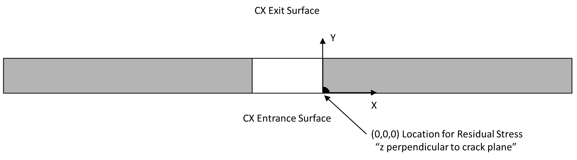
Figure 1. Residual stress coordinate system

Input Data:
Specific input data will be provided to support the analyses:
- Test specimen geometry
  - The test specimen geometries are defined by the drawings contained in Appendix B
- Initial flaw size, shape, location, and orientation
  - Coupons were manufactured with undersized hole diameters and Electro Discharge Machining (EDM) notches at the cold expanded entrance surface of the hole.
  - Precracking was accomplished for all coupons followed by reaming to a final diameter of 0.50” to remove any remnant of the EDM notch.
  - Note: For analysis purposes, the initial surface (x dimension) and bore (y-dimension) crack lengths are provided in Table 2 for each benchmark case, which represent the average test data lengths for each condition. Based on post-test fractography, all analyses should assume an elliptical shaped starting flaw.
- Material Properties
  - Tabulated crack growth rate data, fracture toughness, and other pertinent material properties are contained in Appendix C

- Loading spectrum
  - All loading is constant amplitude with a stress ratio (R) of 0.1
  - Far field applied stresses are listed in Table 1
- Constraints
  - All coupons were tested in a servo-hydraulic fatigue machine with hydraulic wedge grips. The grips engaged 4-inches of each end of the coupon.
- Residual stresses resulting from the contour method
  - A tabulated list of x, y, and Szz on the crack plane (z=0) will be provided
  - For reference, the (0,0,0) location coincides with the cold expansion entrance surface corner of the hole, with the x-dimension oriented radially away from the hole, the y-dimension oriented through the thickness, and the z-direction perpendicular to the crack plane.
  - Note: All dimensions for the residual stress files are in English units (inch, ksi)

Table 2. Starting flaw sizes

Requested Prediction Results:
A summary of the results for each analysis case should include:
- For each point defining the crack front:
  - x-dimension based on the reference location
  - y-dimension based on the reference location
  - z-dimension based on the reference location
  - Kmax (from applied remote stress only)
  - Kresidual
An excel template has been provided to ensure consistency of the data submitted and minimize the collation effort by the subcommittee chair. All results should be provided in English units (inch, ksi, ksi-root(inch)). The coordinate system for the dimensions provided should be located at the crack origin with the x-dimension oriented radially away from the hole, the y-dimension oriented through the thickness, and the z-dimension perpendicular to the crack plane, as shown in Figure 1. The # of points along the crack front and the number of output increments is at the analyst’s discretion, and the template quantities can be adjusted accordingly.
A questionnaire, detailed in Appendix A, is provided to describe the general approach, software, and assumptions utilized in the analyses. This questionnaire should be submitted with the prediction results.

Deadline for Result Submittals:
To provide sufficient time to combine the results from each participant, review the questionnaire, and develop a presentation to facilitate discussions at the 2017 ERSI Workshop, result submissions must be received before July 15, 2017.

Contact Information:
All questions and final submissions should be submitted to rtpilarczyk@hill-engineering.com.

APPENDIX A
QUESTIONNAIRE
Contact Name:
Organization:
Email Address:

Collaborators:
Name:
Organization:
Name:
Organization:

Please provide information about the analyses completed:
- Analysis Software (name and version)
  - FEA software (if applicable):
  - Crack growth software:

- FEA Model Setup (if applicable)
  - Describe the boundary conditions utilized in the FEMs, to include applied loads and constraints

  - Describe the methods to define and control the crack front shape and control meshing along the crack front

- Incorporation of Residual Stresses
  - Describe the methods used to characterize and incorporate the residual stress data provided into the analyses.

- Stress Intensity Calculations
  - Describe the methods used to extract and calculate the stress intensities for applied remote loads and residual stresses

  - Describe the methods used to incorporate the stress intensities into the crack growth code (superposition, etc.)

- Crack Growth Predictions
  - Describe the material model approach used for the crack growth predictions (NASGRO, tabular, etc.) and the assumptions/approach used for “threshold”, stress ratio (R) shift, and negative R behavior.

  - What growth increment was utilized between stress intensity calculations?

- Provide any additional details that may be pertinent to the analyses completed
APPENDIX B
COUPON GEOMETRIES
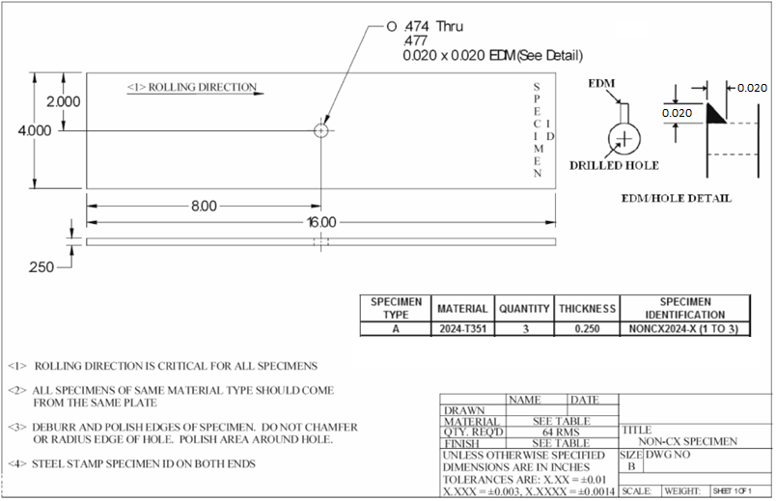
Figure 2. Benchmark Condition 1 Geometry (prior to precracking and final ream)

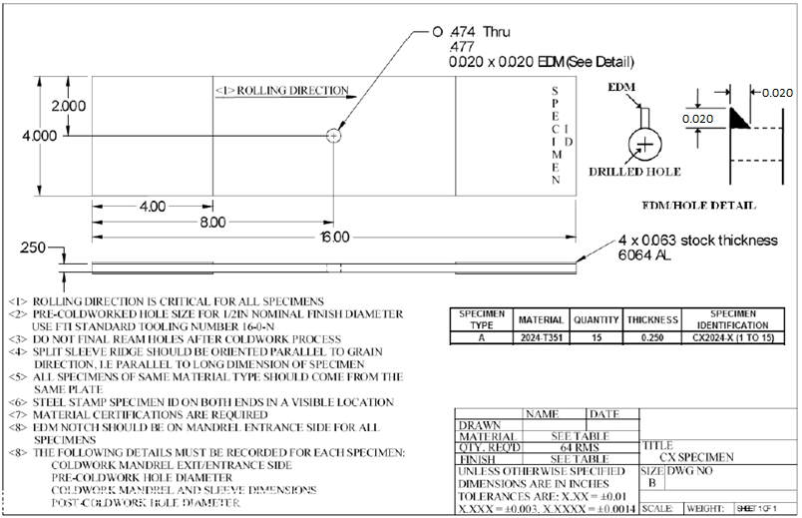
Figure 3. Benchmark Condition 2 Geometry (prior to precracking and final ream)

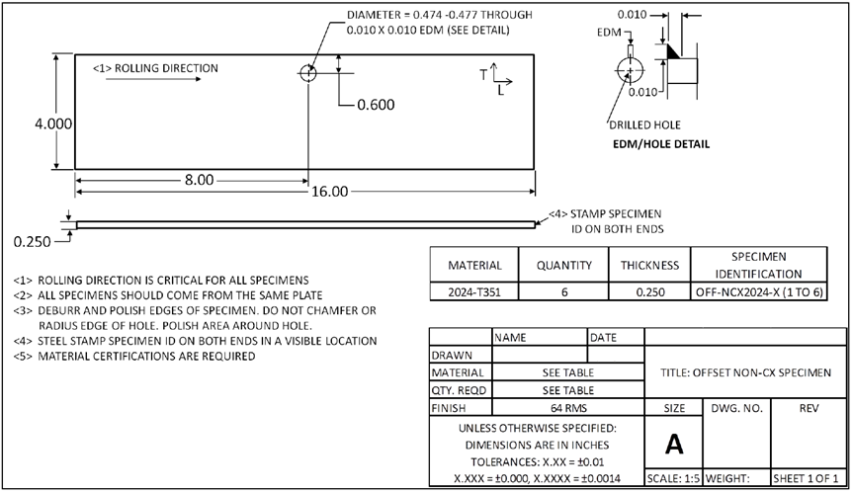
Figure 4. Benchmark Condition 3 Geometry (prior to precracking and final ream)

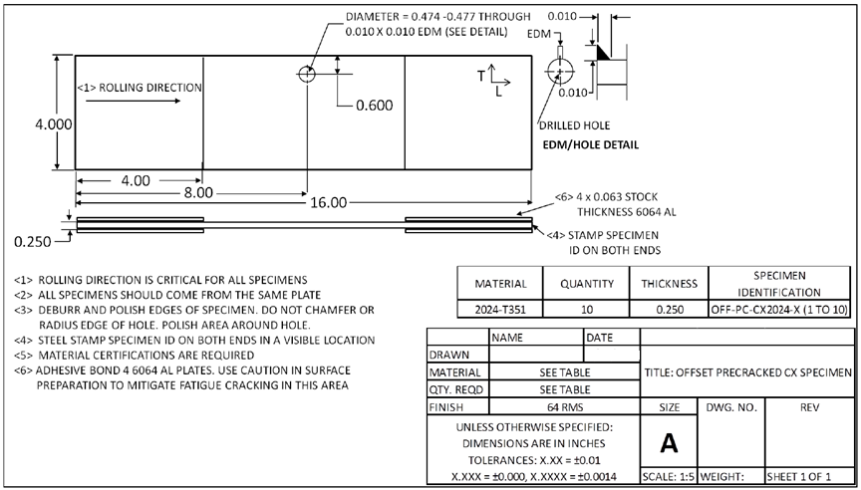
Figure 5. Benchmark Condition 4 Geometry (prior to precracking and final ream)

APPENDIX C
MATERIAL PROPERTIES

Property | Value
Material | 2024-T351 plate
Modulus (ksi) | 10700
Poisson | 0.33
Ultimate Strength (ksi) | 66
Yield Strength (ksi) | 50
Plane Stress Fracture Toughness (ksi-root(inch)) | 80
Plane Strain Fracture Toughness (ksi-root(inch)) | 32
Rlo | -0.25
Rhi | 0.85

da/dN | Stress Ratio (R)
da/dN | -0.25 | 0.1 | 0.5 | 0.8
da/dN | (kmax) | (ΔK)
1.0E-09 | 3.050 | 3.250 | 2.250 | 1.640
4.0E-09 | 3.100 | 3.300 | 2.300 | 1.700
1.0E-08 | 3.150 | 3.350 | 2.350 | 1.760
2.0E-08 | 3.200 | 3.400 | 2.395 | 1.800
4.0E-08 | 3.300 | 3.500 | 2.475 | 1.880
6.0E-08 | 3.400 | 3.600 | 2.560 | 1.980
1.0E-07 | 3.760 | 3.970 | 2.890 | 2.320
2.0E-07 | 4.750 | 4.900 | 3.910 | 3.300
3.0E-07 | 5.440 | 5.600 | 4.500 | 3.870
4.0E-07 | 5.880 | 6.100 | 4.900 | 4.150
6.0E-07 | 6.400 | 6.700 | 5.250 | 4.350
1.0E-06 | 7.000 | 7.400 | 5.600 | 4.700
2.0E-06 | 7.800 | 8.300 | 6.100 | 5.300
4.0E-06 | 9.000 | 9.600 | 7.000 | 6.300
7.0E-06 | 10.300 | 11.000 | 8.000 | 7.100
1.0E-05 | 11.610 | 12.400 | 8.900 | 7.600
2.0E-05 | 16.400 | 17.300 | 11.600 | 8.500
3.0E-05 | 18.700 | 19.500 | 12.900 | 8.950
6.0E-05 | 22.800 | 23.500 | 15.300 | 9.700
1.0E-04 | 26.200 | 26.800 | 17.300 | 10.200
2.0E-04 | 31.400 | 32.000 | 20.400 | 11.100
4.0E-04 | 36.900 | 37.500 | 23.400 | 12.000
6.0E-04 | 40.500 | 41.000 | 25.200 | 12.400
8.0E-04 | 42.500 | 43.000 | 26.200 | 12.700
1.0E-03 | 44.000 | 44.500 | 27.000 | 13.000
2.0E-03 | 50.000 | 50.000 | 29.700 | 13.700
4.0E-03 | 56.000 | 55.500 | 32.600 | 14.500
6.0E-03 | 59.900 | 59.000 | 34.200 | 14.850
1.0E-02 | 63.800 | 62.000 | 35.800 | 15.300
2.0E-02 | 69.200 | 66.000 | 37.500 | 15.600
1.0E-01 | 80.000 | 72.000 | 40.000 | 16.000

